27 June 2019
[85-19]

Supporting document 1

Risk and technical assessment report – Application A1160

Aspergillopepsin I from Trichoderma reesei as a processing aid (enzyme)

Executive summary
DuPont Australia Pty Ltd submitted an application to Food Standards Australia New Zealand (FSANZ) seeking to permit the use of the enzyme Aspergillopepsin I (EC 3.4.23.18) as a processing aid. The commercial enzyme preparation, designated as Acid Fungal Protease (AFP), is derived from a genetically modified strain of Trichoderma reesei overexpressing the gene encoding a native Aspergillopepsin I.

The purpose of AFP is to hydrolyse proteins into peptides in the manufacture of potable alcohol and animal and vegetable protein products.

The food technology assessment concluded that AFP, in the form and prescribed amounts, is technologically justified and has been demonstrated to be effective in achieving its stated purpose. AFP performs its technological purpose during production and manufacture of foods and is therefore appropriately categorised as a processing aid. The enzyme preparation meets international purity specifications.

No public health and safety concerns associated with the use of AFP from genetically modified T. reesei were identified as a result of the hazard assessment.

T. reesei has a long history of safe use in the source of enzyme processing aids, including several that are already permitted in the Code. This fungus is not toxigenic or pathogenic. No extraneous coding genetic material is carried across from the donor organism or through the large number of steps leading to the final genetic modification. The modification involving the insertion of the Aspergillopepsin I gene has been shown to be stably inherited.

There is no evidence of adverse health effects associated with the use of AFP in countries in which it is already approved including in Europe and North America. Bioinformatic searches did not indicate homology with known toxins or food allergens. In vitro incubation of AFP in simulated gastric fluid indicates that AFP is digested, and degraded to small protein fragments, within 30 minutes of incubation at body temperature. Therefore it is anticipated that AFP will be digested like other dietary proteins.

No major allergens are used directly in the preparation of the enzyme, although glucose used in the fermentation medium is derived from wheat. The possibility that traces of wheat protein may be present in the final preparation cannot be excluded.

Based on the reviewed toxicological data, it is concluded that in the absence of any identifiable hazard to health and safety of the general population, an Acceptable Daily Intake (ADI) ‘not specified’ is appropriate. A dietary exposure assessment is therefore not required.

Table of contents
Executive summary i
1 Introduction 2
1.1 Objectives of the assessment 2
2 Food technology assessment 2
2.1 Characterisation of the enzyme 2
2.1.1 Identity of the enzyme 2
2.1.2 Technological purpose of the enzyme 3
2.1.3 Technological justification of the enzyme 3
2.1.4 Use levels 5
2.2 Manufacturing process 6
2.2.1 Production of the enzyme 6
2.2.2 Specifications 7
2.2.3 Activity and stability 8
2.3 Food technology conclusion 9
3 Safety assessment 10
3.1 Objectives for safety assessment 10
3.2 History of use 10
3.2.1 Host organism 10
3.2.2 Gene donor organism(s) 10
3.3 Characterisation of the genetic modification(s) 10
3.4 Safety of Aspergillopepsin I (AFP) 12
3.4.1 History of safe use of the enzyme 12
3.4.2 Bioinformatics concerning potential for toxicity 12
3.4.3 Toxicology studies 12
3.4.4 Genotoxicity assays 13
3.4.5 Potential for allergenicity 13
3.4.6 Approvals by other regulatory agencies 13
4 Discussion 13
5 Conclusions 14
6 References 14

1 Introduction
DuPont Australia Pty Ltd has made an application to FSANZ seeking permission for a new microbial source for the already permitted enzyme, Aspergillopepsin I (EC 3.4.23.18), as a processing aid.

The commercial enzyme preparation designated as Acid Fungal Protease (AFP) in this report, is produced by submerged fermentation of a genetically modified (GM) strain of Trichoderma reesei carrying the gene encoding a native T. reesei protease enzyme, Aspergillopepsin I.

If approved, AFP will be used in the manufacture of potable alcohol and animal and vegetable protein products, at a level consistent with Good Manufacturing Practice (GMP). AFP will be used as a processing aid at low levels, with no technical function in the final food. It has been determined GRAS by a panel of scientific experts in the US and is approved in Denmark and France.

There are two permissions for Aspergillopepsin I as a processing aid in the Australia New Zealand Food Standards Code (the Code), however there is no permission for Aspergillopepsin I sourced from a genetically modified strain of T. reesei. Therefore, any application to amend the Code to permit the use of this enzyme as a food processing aid requires a pre-market safety assessment.

1.1 Objectives of the assessment
The objectives of this risk and technical assessment report were to:
- determine whether the proposed purpose is clearly stated and that AFP achieves its technological function in the quantity and form proposed to be used as a food processing aid
- evaluate potential public health and safety risks that may arise from the use of AFP in the manufacture of potable alcohol and animal and vegetable protein products.

2 Food technology assessment

2.1 Characterisation of the enzyme

2.1.1 Identity of the enzyme
Information regarding the identity of the enzyme provided in the application has been verified using the appropriate internationally accepted reference for enzyme nomenclature, the International Union of Biology and Molecular Biology (IUBMB 2018).

Accepted name: | Aspergillopepsin I
IUBMB/EC number: | 3.4.23.18
CAS registry number: | 9025-49-4
Common names: | Aspergillus acid protease; Aspergillus acid proteinase; Aspergillus aspartic proteinase; Aspergillus awamori acid proteinase; Aspergillus carboxyl proteinase; carboxyl proteinase; Aspergillus kawachii aspartic proteinase; Aspergillus saitoi acid proteinase; pepsin-type aspartic proteinase; Aspergillus niger acid proteinase; sumizyme AP; proctase P; denapsin; denapsin XP 271; proctase
Reaction: | Hydrolysis of proteins with broad specificity

The commercial enzyme preparation is a brown liquid. The carrier for the liquid preparation is glycerol and water.

2.1.2 Technological purpose of the enzyme
Aspergillopepsin I catalyses the hydrolysis of proteins with broad specificity (IUBMB 2018).

The action of AFP in the manufacture of potable alcohol is the hydrolysis of cereal proteins for improved fermentation.

In the manufacture of animal and vegetable protein products, AFP hydrolyses proteins (e.g. casein, whey, soy, pea, wheat) into peptides with improved functional properties.

AFP performs its technological purpose during production and manufacture of foods after which it is inactivated therefore not performing a technological function in the final food.

2.1.3 Technological justification of the enzyme
Enzyme preparations are widely used as processing aids in the manufacture of foods and beverages. Aspergillopepsin I (3.4.23.18), from two different microbial sources, is already permitted in Schedule 18—4(5) of the Code but Aspergillopepsin I from T. reesei is not. T. reesei is currently listed in Schedule 18 as a source organism for a number of other processing aids including Cellulase (EC 3.2.1.4), Endo-1,4-beta-xylanase (EC 3.2.1.8) and β-Glucanase (EC 3.2.1.6). Permitting AFP provides manufacturers of potable alcohol and animal and vegetable protein products with an alternative commercial source of the enzyme. The enzyme chosen by food and beverage manufacturers will depend on a range of commercial considerations including performance in the production of their products and economic factors.

The technological justification for using AFP in potable alcohol production, as indicated by the application, is that it hydrolyses cereal grains to produce benefits such as:
- faster fermentation rates providing higher yields (Figure 1)
- increased availability of starch for hydrolysis
- increased rate of yeast propagation and performance (Figure 2)
- reduced or eliminated need for emulsion breakers
- reduced amount of sources of nitrogen required in fermentation

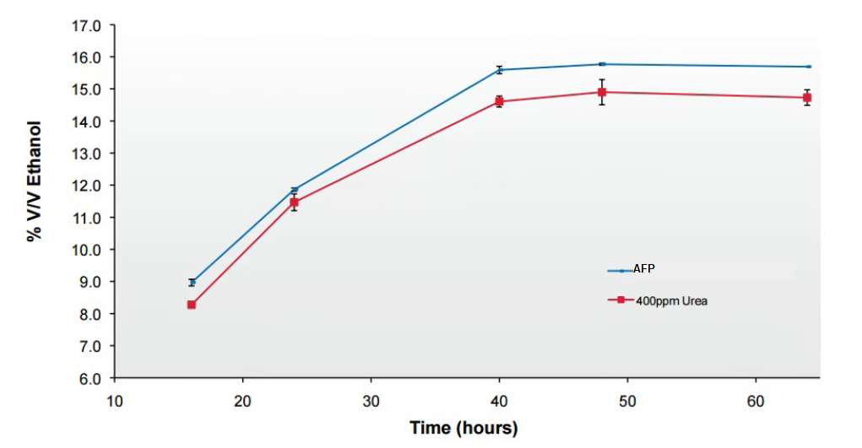

Figure 1 Effect of AFP on Rate and Titer of the production of ethanol via fermentation (control is urea as a source of nitrogen)

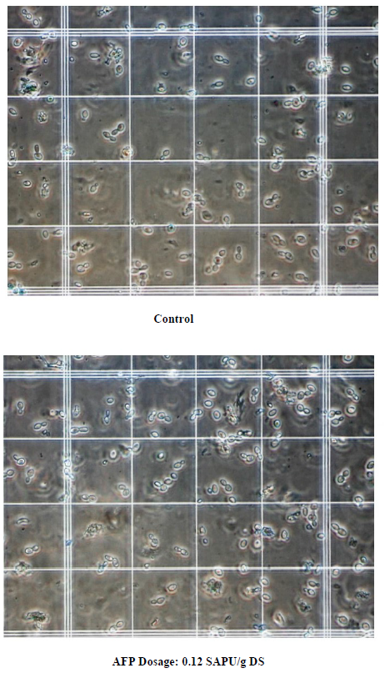

Figure 2 Effect of AFP on yeast propagation
The technological justification for using AFP in the production of animal and vegetable protein products, as indicated by the application, is that it hydrolyses proteins to low molecular weight peptides with improved functional properties such as solubility, emulsification, dispersibility and foaming (Damodaran et al., 2008). This is particularly beneficial for beverage production where sediment and precipitation are aesthetically undesirable, and in sports foods where it is advantageous for protein to be more readily absorbed.

The applicant provided details of studies supporting its claim that use of this enzyme provides these benefits.

2.1.4 Usage levels
Uses of commercial enzyme preparations are typically in accordance with GMP, whereby use is at a level that is not higher than the level necessary to achieve the desired enzymatic reaction. Usage levels are expressed in Total Organic Solids (TOS). Food manufacturers adjust the usage levels depending on the food use, the type and quality of the raw materials used and the enzyme supplier’s recommendations (Table 2).

Table 2 Recommended use levels for AFP

Application | Raw material (RM) | Recommended use levels (mg TOS/kg RM)
Potable alcohol production | Grist | 5 - 50
Protein processing | Vegetable, animal, microbial and milk proteins | 30 - 1000

2.2 Manufacturing process

2.2.1 Production of the enzyme
The manufacturing process for the production of AFP is a three-part process consisting of fermentation (growth of organism and production of enzyme), recovery (separation of cell mass from enzyme and concentration/purification of enzyme) and formulation/ drying (preparation of a stable enzyme formulation) (Figure 3). These are summarised below with full details provided in the application.

Figure 3 Manufacturing process for AFP

Fermentation
The Aspergillopepsin I preparation is produced by submerged fed-batch pure culture fermentation of the genetically modified strain of T.reesei. This process is commonly used for the production of food-grade enzymes.

The fermentation process involves three steps; laboratory propagation (inoculation) of the culture, seed fermentation and primary fermentation. At all stages of the fermentation, microbial growth is checked for correct morphological development of the microorganism and for the presence of any contamination.

Recovery
The recovery process is a multi-step operation designed to separate the enzyme from the microbial biomass and purify, concentrate, and stabilise the food enzyme.

Separation is achieved by either filtration, centrifugation, or a combination of both. The liquid containing the enzyme is then concentrated via ultrafiltration. Diafiltration and carbon treatment may also be used to ensure the enzyme achieves the activity target, remove contaminants and reduce colour. The final recovery step is polish filtration before being dried and agglomerated for formulation.

Formulation
The ultrafiltered concentrate is formulated and packaged for commercial sale. The production process follows standard industry practices and is conducted in accordance with GMP.

2.2.2 Specifications
There are international specifications for enzyme preparations used in the production of food. These have been established by the Joint FAO/WHO Expert Committee on Food Additives (JECFA) Compendium of Food Additive Specifications (JECFA 2016) and the United States Pharmacopeial Convention (USPC) Food Chemicals Codex 11th edition (USPC 2018). Both of these specification sources are primary sources listed in section S3—2 of the Code. Enzyme preparations must meet these specifications.

Table 3 provides a comparison of representative batch analysis of AFP with the international specifications established by JECFA and USPC, as well as those detailed in the Code (as applicable).

Table 3 Product specifications for commercial enzyme preparation

Analysis | Enzyme batch analysis |  |  | Specifications
 |  |  |  | JECFA | USPC | the Code
Lead (mg/kg) | ND  (DL < 0.001) | ND  (DL < 0.001) | ND  (DL < 0.001) | ≤ 5 | ≤ 5 | -
Arsenic (mg/kg) | 0.03 | 0.02 | 0.02 | - | - | ≤1
Cadmium (mg/kg) | ND  (DL < 0.001) | ND  (DL < 0.001) | ND  (DL < 0.001) | - | - | ≤1
Mercury (mg/kg) | ND  (DL < 0.005) | ND  (DL < 0.005) | ND  (DL < 0.005) | - | - | ≤1
Total coliforms (cfu/g) | < 30 |  |  | ≤30 | ≤30 | -
Salmonella (in 25 g) | Absent in 25g |  |  | Absent | Negative | -
Enteropathic E. coli (in 25 g) | Absent in 25g |  |  | Absent | - | -
Antibiotic activity | ND |  |  | Absent | - | -
ª ND = Not detected
^{b} DL = Detection limit

Based on the above results, the enzyme preparation meets international and Code specifications for enzymes used in the production of food.

2.2.3 Activity and stability
Thermally, activity of AFP rapidly decreases at temperatures above 55 °C. It is completely inactivated after incubating at 70°C for 15 minutes (Figure 4).

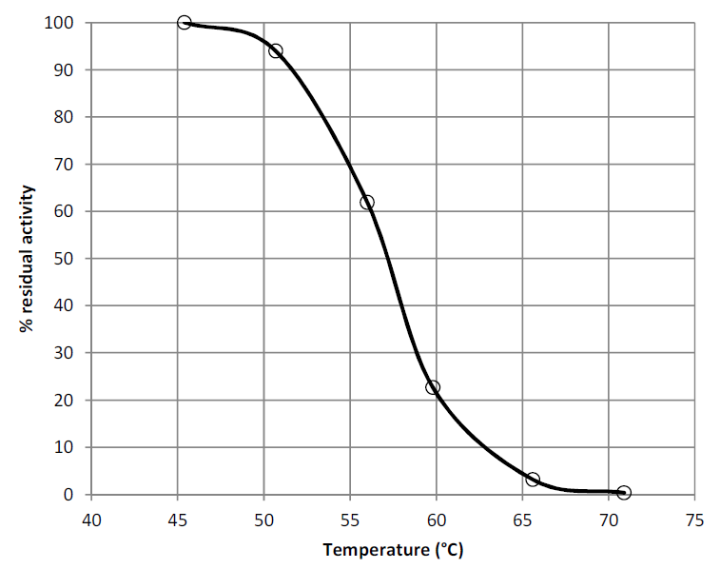

Figure 4 Thermal stability of AFP

AFP is an acid proteolytic enzyme characterised by its ability to hydrolyse proteins under low pH conditions. It is relatively stable in the pH range 3 - 5.8. Optimal stability is seen at the pH interval 3.2 to 4.8 (Figure 5).

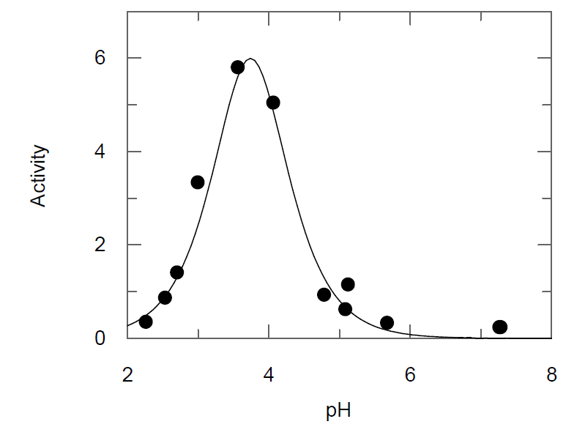
Figure 5 Effect of pH on AFP activity

At 4°C AFP is stable for more than 2 years without significant loss of activity.

2.3 Food technology conclusion
FSANZ concludes that the stated purpose of this enzyme preparation, namely for use as a processing aid in the manufacture and processing of potable alcohol and protein products is clearly articulated in the application. The evidence presented to support the proposed uses provides adequate assurance that AFP, in the form and prescribed amounts, is technologically justified and has been demonstrated to be effective in achieving its stated purpose. AFP performs its technological purpose during production and manufacture of foods after which it is inactivated thereby not performing a technological function in the final food. It is therefore appropriately categorised as a processing aid. AFP meets international purity specifications.

3 Safety assessment

3.1 Objective for safety assessment
The objective of this safety assessment for Aspergillopepsin I is to evaluate any potential public health and safety concerns that may arise from the use of this enzyme, produced by a genetically modified organism, as a processing aid. Consideration is given to the history of use of the host and gene donor organisms, characterisation of the genetic modification(s), and safety of the enzyme.

3.2 History of use

3.2.1 Host organism
T. reesei was first isolated from canvas made from cotton, and the original isolate QM6a is the type strain for T. reesei (Olempska-Beer et al., 2006). In humans T. reesei is not pathogenic. Although some T. reesei strains can produce mycotoxins, most industrial production strains do not produce mycotoxin or antibiotics under conditions used for enzyme production (Nevalainen et al., 1994; Blumenthal 2004).

FSANZ has previously assessed the safety of T. reesei as the source organism for a number of enzymes used as processing aids. Schedule 18 to Standard 1.3.3 of the Code permits the use of the following enzymes derived from T. reesei: cellulase, endo-1,4-beta-xylanase, β-glucanase, hemicellulase multicomponent enzyme and polygalacturonase or pectinase multicomponent enzyme.

3.2.2 Gene donor organism(s)
The gene sequence for Aspergillopepsin I is from T. reesei (the production strain overexpresses the native T. reesei Aspergillopepsin I). As described above, FSANZ has previously assessed T. reesei for a number of enzymes used as processing aids. The NCBI Protein BLAST search of the Aspergillopepsin I gene sequence returned 100% identity to T. reesei QM6a aspartate protease (Aspergillopepsin I is an aspartate protease).

The acetamidase gene (amdS), used as a selection marker for positive transformants, is from Aspergillus nidulans. Its inclusion is regarded as ‘mainstream’ in filamentous fungi systems producing a variety of recombinant gene products (Gryshyna et al., 2016) and there are no safety concerns with acetamidase.

3.3 Characterisation of the genetic modification(s)

3.3.1 Description of DNA to be introduced and method of transformation
Production strain NPSP24 was derived from parental strain, RL-P37 (Sheir-Neiss & Montenecourt 1984) that, itself, originated via classical mutagenesis from strain QM6a and has previously been used by the applicant to manufacture commercial cellulose and xylanase preparations.

RL-P37 then underwent a complex series of genetic modifications via protoplast-mediated transformation procedures (see e.g. Penttilä et al., 1987; Gruber et al., 1990; Smith et al., 1991), using protoplasts prepared from mycelia (Penttilä et al., 1987; Karhunen et al., 1993) to reduce cellulytic activities by inactivating several key genes. As a result of this inactivation, the production strain is unable to survive in the natural environment because it is unable to use cellulose as a carbon source. These modifications are designed to improve efficiency and safety and do not raise any safety concerns. The selection of desired transformants during the development of the final organism was facilitated by using spontaneous mutants that can grow on medium containing the toxic inhibitor 5-fluoroorotic acid (FOA) (together with uridine) as a result of a defective genomic pyr4 gene.

In the final stage of transformation, strain NSP24 was produced by protoplast-mediated transformation of mycelia cells to integrate two purified linear DNA fragments (i.e. free from any vector-derived sequences) each containing two cassettes:

- In the first fragment, the first cassette, driven by the strong native T. reesei promoter from the cellobiohydrolase 1 (cbh1) gene contained the nsp24 coding sequence (plus signal sequence and a putative 78 bp intron) from T. reesei with the T. reesei cbh1 terminator. The second cassette comprised the native orotate phosphoribosyltransferase (pyr2) gene from T. reesei. with its own promoter and terminator. The use of this second gene allows selection of vectors on a medium containing uridine (see e.g. Jørgensen et al., 2014) and does not raise any safety concerns. In addition, the fragment also contained several short recombination site cloning remnants.

- In the second fragment, the first cassette contained the same genetic elements as those described for the first fragment. The second cassette comprised the acetamidase gene (amdS) from A. nidulans (Kelly and Hynes, 1985), with the cbh1 promoter and terminator. This second gene allows for selection of transformants on acetamide-containing media. In addition, this cassette also contained several short recombination site cloning remnants.

3.3.2 Characterisation of inserted DNA
At all stages of the transformations, Southern blot analysis with appropriate controls (and following restriction enzyme digestion and polymerase chain reaction) was undertaken to ensure no extraneous DNA sequences had been incorporated. At the final stage, Southern blot analysis (see section 3.3.3) indicated that in NSP24: a) no vector DNA was present; b) there was no rearrangement of the nsp24 expression cassette; and c) more than one intact copy of the nsp24 gene had been integrated into the genome.

3.3.3 Genetic stability of the inserted gene
T. reesei strains are widely used in biotechnological processes because of their known stability.

Broth samples were taken prior to and after 10-day fermentations (3 replicates) in 100 mL shake flasks mimicking commercial fermentation conditions. It was estimated the fermentations represented 63 cell doublings, which was more than twice the number that occur during large-scale commercial fermentation.

Genomic DNA was isolated, restriction enzyme digested and analysed by Southern blotting using a digoxigenin-labelled hybridisation probe comprising the entire nsp24 gene. Any rearrangement in the inserted nsp24 expression cassette DNA would result in a change of the expected banding pattern. In particular, new bands would appear as a result of expression cassette integration at a new site in the genome creating new flanking DNA fragments.

No change in band pattern was observed between the genomic DNA samples extracted from shake flask culture before serial transfer culture and those extracted after 10 days of serial shake flask culture. This indicates that there had been no insertion of the expression cassette at new sites in the T. reesei genome during fermentation representative of or exceeding the number of cell doublings that occur at commercial scale.

3.4 Safety of Aspergillopepsin I (AFP)

3.4.1 History of safe use of the enzyme
The US FDA responded in September 2010 with no questions to a GRAS notification (GRN 000333) for the same enzyme (AFP) that is the subject of this application, synthesized from a closely related strain of T. reesei. AFP was approved for use in France and in Denmark in April 2017. The enzyme has been used, largely for potable alcohol consumption, in Canada, Brazil, Argentina, Thailand and some European countries. No adverse consequences of the use of AFP have been reported.

AFP shares 51% identity with an aspergillopepsin that is approved in the Code, that of Aspergillus oryzae.

3.4.2 Bioinformatics concerning potential for toxicity
Bioinformatic analyses for toxin homology of the amino acid sequence of the mature enzyme were conducted. A BLAST search against the Uniprot annotated Protein Knowledge database with a threshold E-value of 0.1 yielded numerous hits of proteases, but none of the top 1000 hits was annotated as a toxin or a venom. A BLAST search was also conducted against the Uniprot animal toxin database. This yielded two hits, but the E-value was not < 0.1 or the identity > 35% for either hit.

3.4.3 Toxicology studies
No animal toxicity studies were submitted for AFP.

Simulated gastric fluid digestion of AFP (Dupont 2018) Regulatory status: Non-GLP

The susceptibility of AFP to breakdown in simulated gastric fluid was investigated in this study. The test material was the same as the AFP which is the subject of this application. For the purpose of the test, AFP was prepared at a concentration of 5 µg/mL in milliQ water. As a positive control protein, BSA was prepared at the same concentration. Two batches of Gastric Control (G-Con) solution were prepared by mixing 200 mg NaCl and 0.7 mL concentrated HCl in 25 mL water, titrating to pH 1.2 with dilute HCl, and bringing to a final volume of 50 mL with water. Two batches of Simulated Gastric Fluid (SGF) solution were prepared by dissolving pepsin in G-Con to a concentration of 10,000 units/mL.
The following incubations were conducted in duplicate:
- SGF, 0 min incubation
- SGF, 30 min incubation
- AFP in SGF, 0 min incubation
- AFP in SGF, 30 min incubation
- AFP in G-Con, 30 min incubation
- BSA in SGF, 0 min incubation
- BSA in SGF, 30 min incubation
- BSA in G-Con, 30 min incubation
All incubations were carried out at 37°C. At the end of incubation, reactions were stopped by the addition of stop solution, sample buffer and sample reducing agent, with mixing by vortex. Assay samples were heated to 99°C for 5 min and stored under refrigeration before being analysed by SDS-polyacrylamide gel electrophoresis (SDS-PAGE) against protein standard markers.

SGF control assays showed protein bands at approximately 38 kDa, confirming the stability of pepsin during the incubation. BSA was intact in SGF at 0 min but completely digested, and degraded to <6 kDa, after 30 min incubation. Similarly, AFP was present at 0 min but completely digested, and degraded to <6 kDa (the smallest marker of molecular weight) used, after 30 min incubation. AFP also showed some degradation after 30 min incubation in G-Con, despite the absence of pepsin. It was considered that this could be due to heat. It was concluded that AFP is susceptible to digestion in SGF.

3.4.4 Genotoxicity assays
No data on genotoxicity of AFP were submitted.

3.4.5 Potential for allergenicity
An 80 amino acid sliding window search of the Food Allergy Research and Resource Program (FARRP) AllergenOnline database resulted in three hits. AFP showed significant homology to Aspergillopepsin I from Aspergillus fumigatus, with a maximum identity of 63.79%, and an E score of 1.4 x 10⁻⁷⁰. AFP shared 42.51% sequence identity with Pepsin A from Sus scrofa, with an E score of 4.3 x 10⁻²⁰, and shared 40.50% with endopeptidase from Rhizopus oryzae, with an E score of 1.1 x 10⁻²⁰. These values indicate potential for cross-reactivity. A literature search located references to allergy to endopeptidase from Rhizopus oryzae as a respiratory allergen but not a food allergen. The risk of food allergy associated with cross-reactivity between a food enzyme processing aid and respiratory or dermal allergens is considered to be very low (Dauvrin et al., 1998; Bindslev-Jensen et al., 2006).

No major allergens are used directly in the preparation of the enzyme, although glucose used in the fermentation medium is derived from wheat. The possibility that traces of wheat protein may be present in the final preparation cannot be excluded.

3.4.6 Approvals by other regulatory agencies
This information has been presented in subsection 3.4.1.

4 Discussion
There are no public health and safety concerns for the general population associated with the use of AFP derived from T. reesei overexpressing the gene encoding a native T. reesei, Aspergillopepsin I.

T. reesei is not pathogenic, production strains are not toxigenic, and the fungus has a long history of safe use in the production of enzyme processing aids, including several that are already permitted in the Code. No extraneous coding genetic material is carried across from the donor organism or through the large number of steps leading to the final genetic modification. The modification involving the insertion of the Aspergillopepsin I gene has been shown to be stably inherited.

There is no evidence of adverse health effects associated with the use of AFP in countries in which it is already approved including in Europe and North America. Bioinformatic searches for AFP did not indicate homology with known toxins, venoms or food allergens. In vitro incubation of AFP in simulated gastric fluid showed that AFP is not stable but is digested, and degraded to small protein fragments, within 30 minutes of incubation at body temperature. Therefore it is anticipated that AFP will be digested like other dietary proteins.

Toxicology studies on AFP were not submitted by the Applicant but are not routinely required by FSANZ where there is evidence of a history of safe consumption and enzyme degradation has been demonstrated in appropriate digestion systems.

No major allergens are used directly in the preparation of the enzyme, although glucose used in the fermentation medium is derived from wheat. The possibility that traces of wheat protein may be present in the final preparation cannot be excluded.

5 Conclusions
Based on the reviewed toxicological data, it is concluded that in the absence of any identifiable hazard to health and safety of the general population, an Acceptable Daily Intake (ADI) ‘not specified’ is appropriate. A dietary exposure assessment is therefore not required.

It is concluded there are no public health or safety concerns associated with the use of AFP as a food processing aid.

6 References
Bindslev-Jensen C, Skov PS, Roggen EL, Hvass P, Brinch DS (2006) Investigation on possible allergenicity of 19 different commercial enzymes used in the food industry. Food and Chemical Toxicology 44: 1909-1915.
Blumenthal CZ (2004) Production of toxic metabolites in Aspergillus niger, Aspergillus oryzae, and Trichoderma reesei: Justification of mycotoxin testing in food grade enzyme preparations derived from the three fungi. Regulatory Toxicology and Pharmacology 39:214–228
Damodaran S, Parkin K, & Fennema OR (2008) Fennema's Food Chemistry. Boca Raton: CRC Press/Taylor & Francis pp. 293–295
Dauvrin T, Groot G, Maurer K-H, de Rijke D, Ryssov-Nielsen H, Simonse M, Sorensen TB (1998) Working group on consumer allergy risk from enzyme residues in food. An AMFEP expert group evaluation study.
Gruber F, Visser J, Kubicek CP, de Graaff LH (1990) Cloning of the Trichoderma reesei pyrG gene and its use as a homologous marker for a high-frequency transformation system. Current genetics 18(5):447–451
Gryshyna A, Kautto L, Peterson R, Nevalainen KMH (2016) On the safety of filamentous fungi with special emphasis on Trichoderma reesei and products made by recombinant means. In Schmoll M, Dattenböck C (eds) Gene expression systems in fungi: advancements and applications. Fungal Biology. Springer, Cham
IUBMB (International Union of Biochemistry and Molecular Biology) Enzyme Nomenclature for EC 3.4.23.18. Accessed 12 November 2018
JECFA (2016) Combined compendium of food additive specifications Accessed 15 November 2018
Jørgensen MS, Skovlund DA, Johannesen PF, Mortensen UH (2014) A novel platform for heterologous gene expression in Trichoderma reesei (Teleomorph Hypocrea jecorina) Microbial Cell Factories 13(1): pp33. doi: 10.1186/1475-2859-13-33
Karhunen T, Mäntylä A, Nevalainen KMH, Suominen PL (1993) High frequency one-step gene replacement in Trichoderma reesei. I. Endoglucanase I overproduction. Molecular & General Genetics 241 (5-6): 515–522
Kelly JM, Hynes MJ (1985) Transformation of Aspergillus niger by the amdS gene of Aspergillus nidulans. The EMBO Journal 4(2):475–479
Nevalainen H, Suominen P, Taimisto K (1994) On the safety of Trichoderma reesei. Journal of Biotechnology 37:193–200
Olempska-Beer ZS, Merker RI, Ditto MD, DiNovi MJ (2006) Food-processing enzymes from recombinant microorganisms – A review. Regulatory Toxicology and Pharmacology 45:144–158
Pariza, M.W. and Johnson, E.A. (2001). Evaluating the safety of microbial enzyme preparations used in food processing: update for a new century. RegulatoryToxicology and Pharmacology. 33: 173 – 186.
Penttilä M, Nevalainen H, Rättö M, Salminen E, Knowles J (1987) A versatile transformation system for the cellulolytic filamentous fungus Trichoderma reesei. Gene 61(2):155–164
Sheir-Neiss G, Montenecourt BS (1984) Characterization of the secreted cellulases of Trichoderma reesei wild type and mutants during controlled fermentations. Applied Microbiology and Biotechnology 20(1):46–53
Smith JL, Bayliss FT, Ward M (1991) Sequence of the cloned pyr4 gene of Trichoderma reesei and its use as a homologous selectable marker for transformation. Current Genetics 19(1):27–33
USPC (2018) Food Chemicals Codex 11th Edition, United States Pharmacopeial Convention, Rockville, MD. Accessed 23 January 2019

International Union of Biochemistry and Molecular Biology.
Enzyme Commission, internationally recognised number that provides a unique identifier for enzymes
Chemical Abstracts Service Registry Number, internationally recognised number that provides a unique identifier for organic and inorganic chemical substances
Diafiltration is a technique that uses ultrafiltration membranes to completely remove, replace, or lower the concentration of salts or solvents from solutions containing proteins, peptides, nucleic acids, and other biomolecules.

